Systems of Equations Posttest: Name:_______________________

1) Solve the system of linear equations.
y = -x + 4 y = 2x – 8
a) (4,0) b) (0,4) c) (-4,0) d) (0,-4)

2) Solve the system of linear equations.
y = 4x + 6 y = 2x + 2
a) (2,2) b) (2,-2) c) (-2,2) d) (-2,-2)

3) Solve the system of linear equations.
2y = x + 3 2x + y = 4
a) (2,1) b) (1,2) c) (-2,-1) d) (-1,-2)

4) Which system of linear equations has NO solution?

a) a – b =2 b) a – b = 3 c) –a + b = -2 d) a + b =3
b = -a – 3 a + b = -2 b = a + 3 -a + b = 2

5) Which system of linear equations has infinitely many solutions?

a) 4x + 6y = 8 b) 2x – 3y = 3 c) 2x + y = 5 d) -2x – y = -1
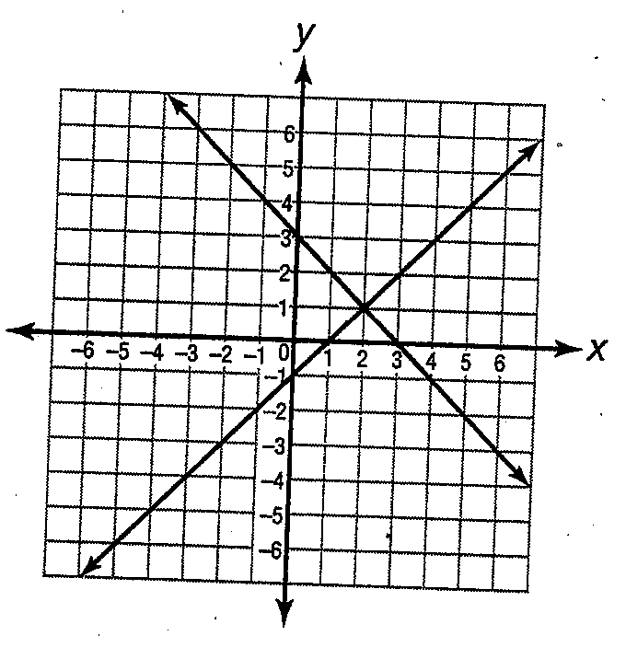
6x – 9y = 12 2/3x – y = 1 4x + 2y = 5 4x – 2y = 2

6) Which system of linear equations is graphed?

a) y = x + 3 b) y = -x + 3
x + y = 1 x – y = 1

c) y = x – 3 d) y = -3x
x – y = 1 x + y = -1

7) Which system of linear equations has only one solution?

a) x + 2y = -1 b) 3x – y = 9 c) y = 2x – 3 d) x – y =4
2x + 5y = 0 6x – 2y = 6 -4x + 2y = -6 y = x + 4
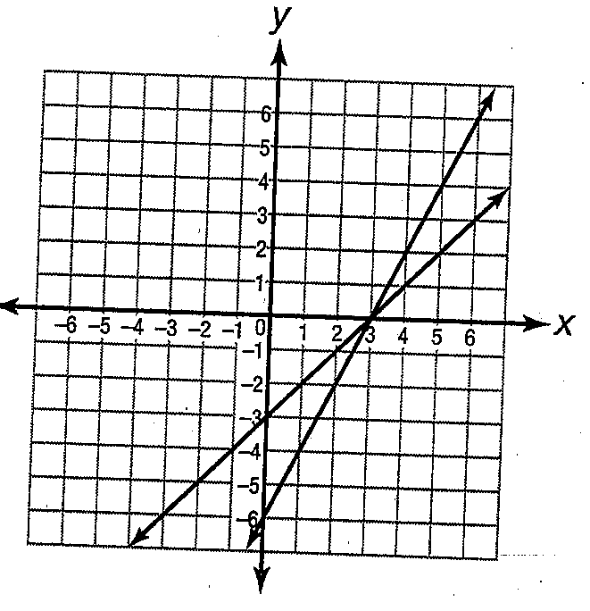
8) Which system of linear equations is graphed?

a) x + y = 3 b) -3x + y = 3
2x + y = -6 2x – y = -6

c) –x – y + -3 d) –x + y = -3
2x + y = 3 2x – y = 6

9) What is the solution of this system?
y = x – 2 and x = 17 – 4y

a) (5,3) b) (3,-5) c) (-3, -5) d) (-5,3)

10) Solve the system of equations.
y = x + 5 and 2y – x = 13

a) (-3,-8) b) (-3,8) c) (3,-8) d) (3,8)

11) What is the solution of this system?
8x + 3y = -9 and -8x + y = 29

a) (3,-5) b) (3,5) c) (-3, -5) d) (-3,5)

12) Solve the system of equations.
3x = y + 4 and x – y = 6

a) (-7,-1) b) (-1,-7) c) (1,7) d) (7,1)

13) Which system has the solution (-3, -10)?

a) x + y = 7 b) x – y = 7 c) x – y = 7 d) x + y = -7
x + y = 19 3x – y = -19 3x + y = -19 3x – y = 19

14) Which system has NO solution?

a) 6x – 7y = 5 b) 6x – 7y = 5 c) 6x + 7y = 5 d) 6x + 7y = 5
12x – 14y = 10 12x – 14y = -10 18x – 21y = 15 12x + 14y = 10

15) Which system has infinitely many solutions?

a) 6x – 3y = 9 b) 6x – 3y = 6 c) 6x – 3y = 9 d) 6x + 3y = 9
4x + 2y = 6 4x – 2y = 9 4x – 2y = 6 4x + 2y = 3

16) The perimeter of a rectangle deck is 175 feet. The length of the deck, l, is 6 feet longer than 2 times the width, w. Which system of equations can be solved to determine the length and width, in feet, of the deck?

a) 2l + 2w = 175 b) 2l + 2w = 175 c) 2l + 2w = 175 d) 2l + 2w = 175
l = 2 – 6w l = 2w – 6 l = 6 – 2w l = 6 + 2w

- Solve for length and width of the deck: l = 181/3 w = 163/3

17) A number, x, is 11 less than 3 times a smaller number, y. The sum of the numbers is 24. Which system of equations can be solved to determine x and y?

a) x + y = 24 b) x+ y = 24 c) x+ y = 24 d) x+ y = 24
x = 3y – 11 x = 11 – 3y x = 11 + 3y x = (11 – 3)y

- Solve for x and y: x = 61/4 y = 35/4

18) A box contains 22 coins consisting of quarters and dimes. The total value of the coins is $3.55. Which system of equations can be solved to determine the number of quarters, q, and the number of dimes, d, in the box?

a) d + q = 22 b) d + q = 22 c) d + q = 3.55 d) d + q = 22
10d + 25q = 3.55 .10d + .25q = 3.55 10d + 25q = 22 .10d + .25q = 355

19) Mr. Harris bought 4 hot dogs and 3 burgers for his family from a refreshment stand at the beach and paid $27. Ms. Sanders bought 7 hot dogs and 4 burgers for her family at the same refreshment stand and paid $41. Which system of equations can be solved to determine h, the price of a hotdog, and b, the price of a burger?

a) 4h + 3b = 27 b) 4h – 3b = 27 c) 4h + 3b = 27 d) 4h – 3b = 27
7h – 4b = 41 7h – 4b = 41 7h + 4b = 41 7h + 4b = 41

20) Roland has 21 coins consisting of dimes and quarters. The number of dimes is 3 more than twice the number of quarters. Which system of equations can be solved to determine d, the number of dimes, and q, the number of quarters?

a) d + q = 21 b) d + q = 21 c) d + q = 21 d) d + q = 21
q = 2d + 3 d = 2q + 3 d = 2q – 3 d = 3q + 2

21) Kendra is considering enrolling in two acting schools. One school requires a registration fee of $75 and charges $18 per class. The other school requires a registration fee of $40 and charges $22 per class. Which system of equations can be used to determine how many classes she has to take before one school becomes a better deal?

a) y = 18x + 75 b) y = 18x – 75 c) y = 75x + 18 d) y = 75x – 18
y = 22x + 40 y = 22x – 40 y = 40x + 22 y = 40x – 22

22) Manny has $2.30 in dimes and quarters. The total number of coins is 2 less than twice the number of dimes. Which system of equations can be solved to determine q, the number of quarters, and d, the number of dimes?

a) .10d + .25q = 2.30 b) .10d + .25q = 2.30
d + q = 2d + 2 d + q = 2d – 2

c) .10d + .25q = 2.30 d) .10d + .25q = 2.30
d + q = 2d d + q = 2 – 2d

23) The Mendez family is going to the movies. Adult tickets cost $9 and children’s tickets cost $6. There are 6 people in the family, and they spend a total of $48 on tickets. Which system of equations can be solved to determine a, the number of adult tickets, and c, the number of children’s tickets?

a) 9a + 6c = 28 b) 9a + 6c = 28 c) 6a + 9c = 28 d) 6a + 9c = 28
a + c = 6 a – c = 6 a + c = 6 a – 6 = c

24) Gina bought 5 hot dogs and 3 soft drinks at the ball game for $11.50. Renaldo bought 4 hot dogs and 2 soft drinks for $8.50. How much does a single hot dog and a single drink cost?

a) hot dogs: $1.25 b) hot dogs: $1.25 c) hot dogs: $1.50 d) hot dogs: $1.50
drinks: $1.50 drinks: $1.75 drinks: $1.25 drinks: $1.75

25) The bookstore hopes to sell at least 30 binders and calculators each week. The store also hopes to have sales revenue of at least $200 in binders and calculators. How many binders and calculators could be sold to meet both of these sales goals if binders cost $3.65 a piece and calculators cost $14.80 a piece?

a) 25 binders b) 22 binders c) 12 binders d) 28 binders
5 calculators 9 calculators 15 calculators 6 calculators

